Auditing with Rewards for Honesty and Punishments
for Cheating
Austin Henderson

Supplemental Materials

S1 Theory 1
S3 Experimental Procedure and Instructions 4
S3 Power Calculations 6
Minimum Detectable Effects 6
S4 Results: Power 7
H1: The rate of cheating will be significantly lower when the gap in expected value between cheating and honesty is substantially reduced. 7
H2: Very small changes in the expected value of cheating, as from a 1% chance of audit, will not lead to a significant difference in the observed rate of cheating. 7
H3: Equal differences in expected values between honesty and cheating will lead to equal rates of cheating between treatment groups who face punishment and reward incentives. 8
S5 Experiment 2: Social Norms 9
Experiment 2: Theory 9
Experiment 2: Experimental Procedure 10
Experiment 2: Results 14
Experiment 2: Discussion 18
S6 Potential Explanations 19
S7 Figures and Tables 21
S8 Works Cited 22

S1 Theory
Below, I present the formal model which generated the hypotheses presented in the main text and which was used to design the experiment, then consider alternative theoretical perspectives.
Utility functions in this model have standard properties, and outcomes are dollar denominated, with a strictly positive utility value of each dollar. Risk aversion is assumed to not play a significant role in such small stakes (Rabin, 2000), a common assumption in related studies (e.g. Laske, Saccardo, and Gneezy 2018). When the expected utility of being honest, EU_{h}, is larger than the expected utility of cheating, EU_{c}, the individual is honest, and vice versa. The monetary components of this decision are the baseline (i.e. not related to audits) monetary outcomes if they are honest, X, and if dishonest, Y. By construction, Y>X. The probability that their action is audited and whether they were truthful detected is p, and the consequence for detected behavior is M. The intrinsic cost of cheating is L and is assumed to be fixed for each individual.
First, consider the model with participants facing a chance of rewards r: the expected utility of being honest (1) and cheating (2) are:

EU_{h,r} = (1 - p)*U(X) + p*U(X + M) (1)

EU_{c,r} = U(Y - L) (2)

Similarly, here is the model with a chance of punishment k, with the expected utility of being honest in (3) and cheating in (4)

EU_{h,k} = U(X) (3)

EU_{c,k} = (1 - p)*U(Y - L) + p*U(Y - M - L) (4)

The analysis and predictions made by changing auditing incentives (M) or probability of detection (p) are produced by taking the first order derivative of those terms.

∂EU_{h,r} /∂p = -U(X) + U(X + M) > 0 (5)

∂EU_{h,r} /∂R = p*U'(X + M) > 0 (6)

∂EU_{c,m} /∂p = -U(Y - L) + U(Y - M - L) < 0 (7)

∂EU_{c,m} /∂M = -p*U'(Y - M - L) < 0 (8)

Adding a reward and positive probability of detection will increase the attractiveness of being honest, and conversely adding a punishment with a positive chance of detection will decrease the attractiveness of cheating.
Thus, the EV of honesty and cheating was set in the experiment such that the EV gain from cheating would be directly comparable for several sets of treatments, as summarized in Table S1 below (appears as Table 1 in the main text).

Treatment | EV of Honesty | EV of Cheating
1% Chance of Punishment | $0.50 | $1.00
10% Chance of Punishment | $0.50 | $0.99
1% Chance of Small Reward | $0.51 | $1.00
10% Chance of Small Reward | $0.60 | $1.00
1% Chance of Large Reward | $0.60 | $1.00
1% Chance Large Reward or Punishment | $0.60 | $0.99
Table S1. Expected values of honesty and cheating in each treatment

S.2 Alternative behavioral Models
While this relatively straightforward expected utility model is useful to generate baseline predictions and to link this work to other auditing research, the findings of other behavioral research on the efficacy of rewards and punishments, as well as some behavioral models, provide competing predictions. Andreoni, Harbaugh, and Vesterlund (2003) found in a laboratory proposer-responder game that introducing the possibility of responders to send rewards was fairly ineffective in inducing higher transfers from proposers, but that possible punishments were more effective, and the combination of punishments and rewards was most effective. More theoretically, loss aversion (Kahneman and Tversky, 1979), which describes the tendency of individuals to prefer avoiding losses to earning equivalent gains, has been found in a wide variety of economically important contexts, including financial decision-making (Benartzi and Thaler, 1995), seller behavior in the housing market (Genesove and Mayer, 2001), and in abstract laboratory settings (Gneezy and Potters, 1997). In this context, loss aversion predicts that equivalently sized punishments will have a larger behavioral effect than rewards. Relatedly, risk-as-feelings (Lowenstein et al., 2001) predicts that individuals may process risks fearfully, thus making them more effective than rewards, a hypothesis supported by a real-world tax auditing study (Bergolo et al., 2017).
Some empirical findings and behavioral models also predict that small incentives may have an outsized impact. The inverse s-shaped probability weighting function of Kahneman and Tversky (1979) captures that individuals tend to treat low probability outcomes as if they were more likely, thus potentially increasing the efficacy of unlikely incentives, both rewards and punishments. Previous studies have also found that specific features of a reward structure are more heavily weighted, for instance, people are more concerned with the size of a top prize rather than the expected value of a lottery ticket (Garrett and Sobel, 1999; Forest, Simmons, and Chesters, 2000). An emphasis on the potential upside of a reward, rather than just an evaluation of expected value, might make a small probability of a large reward more effective than a larger probability of a small reward.
Recent research has expanded upon the outcome-oriented Becker model to identify other factors in the decision to cheat, and include self-image, morality, and social-status (e.g. Dufwenberg, 2016; Shalvi, Eldar, and Bereby-Meyer, 2012; Gneezy, Kajackaite and Soble, 2018; Khalmetski and Sliwka, 2019). A branch of the literature in behavioral economics studies the impact of these intrinsic motivations on cheating, and finds that most individuals are to some degree averse to lying or cheating (e.g. Gneezy, 2005; Battigalli, Charness, and Dufwenberg, 2013; Fischbacher and Follmi-Heusi, 2013; Cappelen, So rensen, and Tungodden, 2013). There is also evidence that there is a distribution of types of cheaters, with some who will never cheat, some who will cheat given sufficiently large incentives to do so, and some who will always cheat given any positive incentive (Gneezy et al., 2013). Moreover, there is experimental evidence that the cost of lying is fixed and insensitive to the stakes at hand (Kajackaite and Gneezy, 2017). I use these experimental findings on the intrinsic cost of cheating to provide broad power calculations which predict whether effects will be detectable (see Supplemental Materials S3).

S3 Experimental Procedure and Instructions
On Amazon MTurk, participants were told they could participate in a task that would take 2 minutes and have a $0.10 payoff for completion. Upon accepting the task, they were given a link to Qualtrics, where the experiment took place. Participants there were given informed consent and then, if they accepted, proceeded to the experiment.
Participants were first informed that they would see on the next screen with 0.5 probability an image of a large letter H or a T, and that they would be asked to report which letter they saw. For reporting an H, they would receive a low payment (either $0.50 or $0.60), and for reporting a T they would receive a high payment (either $1.00 or $1.10). Amounts varied for a H or T in order to make the expected gain of cheating equivalent between treatments. There were seven treatments, and participants were randomly assigned to one just one, in that they never saw other conditions. This determined the instructions which followed, which are summarized in Table 2 along with the number of participants in each treatment.

Treatment | Description
Control | Participants were told that their answers would not be checked for veracity.
1% Chance of Punishment | Participants were told that there was a 1% chance that their report would be audited, and if they were found to be dishonest they would be penalized by $1.00 (thus reducing their earnings to $0.10 for participating).
10% Chance of Punishment | Participants were told that there was a 10% chance that their report would be audited, and if they were found to be dishonest they would be penalized by $1.00 (thus reducing their earnings to $0.10 for participating).
1% Chance of Small Reward | Participants were told that there is a 1% chance that their report would be audited, and if they were found to be honest they would receive a bonus of $1.00.
10% Chance of Small Reward | Participants are told that there is a 10% chance that their report will be audited, and if they were found to be honest they would receive a bonus of $1.00.
1% Chance of Large Reward | Participants are told that there is a 1% chance that their report will be audited, and if found to be honest they would receive a bonus of $10.00.
1% Chance Large Reward or Punishment | Participants are told that there is a 1% chance that their report will be audited, and if found to be honest they would receive a bonus of $10.00, or if dishonest, a penalty of $1.00.
Table S1. Summary of Treatments

When ready, they clicked to proceed to the next screen, which displayed either an H or a T, and a multiple-choice button asking which letter was displayed. After responding, participants proceeded to the next screen, which gave them a number to enter on MTurk to coordinate payment, and the experiment was concluded.

Screenshots of the experimental instructions are below.

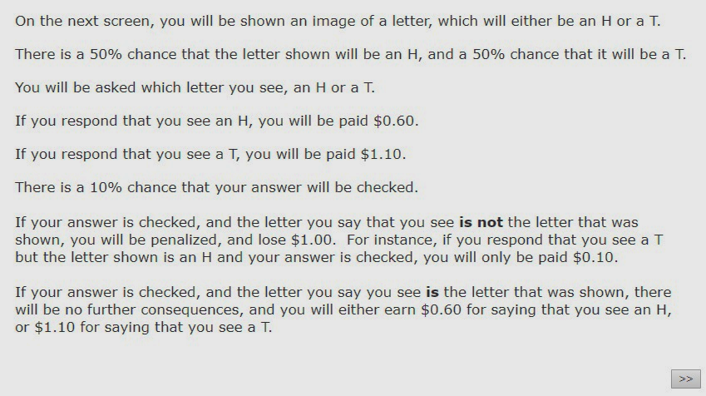
Figure S1 First instruction screen for cheating game.


Figure S2 Second instruction screen for cheating game.

S3 Power Calculations
Detecting treatment effects in this experiment is dependent upon the fraction of participants who are responsive to changes in their incentives to cheat. Moreover, generating hypotheses of the detectability of treatment effects require making reasonable assumptions about the distribution of lying costs.
To justify hypotheses based on a prediction of whether the change in the fraction of participants who choose to cheat will be detectable given a change in the incentives, I refer to previous experimental findings and argue for changes of plausible magnitudes, as well as posit a uniform distribution of lying costs within the incentive space (i.e. the outcome space between reporting heads and tails). These experiments were not designed to make explicit, generalized claims about the true rate of individuals who will cheat at a given incentive, however, they do present a range of observed cheating rates at given incentives, and thus provide a reasonable context to Experiment 1.
Three reports find that in laboratory experiments 33-53% of participants will not lie at the maximum experimental incentive, and 3-8% of participants will lie given any positive incentive (Gneezy et al. 2013; Kajackaite and Gneezy, 2017; Laske, Saccardo, and Gneezy, 2018). The participants of interest in this study are those who will respond to the level of incentives, and based on this prior experimental data, may make up between 39% and 64% of the total. Taking a middle ground, let us assume 50% of the participants in the study are sensitive to the probability and consequences of detection.
In this model, changes in the propensity to cheat in participants facing a 1% chance of audit would be from those participants with a positive, but very small cost of lying, essentially those participants for whom the original expected gain from cheating of $0.50 placed them exactly on the margin. The observed proportion of cheaters in the control treatment was 23.77%, with a sample size of N = 125. At power equal to 0.8, a decrease in cheating of 13.29pp is the Minimum Detectable Effect (MDE), and at power equal to 0.5 a decrease in cheating of 9.71pp is the MDE. Thus if participants are purely making their decisions based on expected value with standard risk preferences, it must be that at minimum 9.71pp of participants were on the margin in order to detect the effect. Observing such an effect would be inconsistent with prior research, which has found that larger proportional and absolute changes (e.g. the incentive to cheat increases by 10pp) rarely produce changes of such magnitude. Assuming a uniform distribution and that 50% of participants are sensitive to the level of incentives, the number of participants who would change from cheating to honesty is equal at each $0.01 interval between $0.50 and $0.60. That is, for each decrease in the expected gains from cheating of $0.01, 1pp fewer participants will choose to cheat. This suggests that a 1% chance of audit there should not be a detectable change according to the model.

Minimum Detectable Effects
Based on the observed proportion of cheaters in the control treatment (23.77%) I calculate the MDE, which is the smallest possible change in the proportion of cheaters detectable at a given power at the 0.05 significance level using a Pearson's 𝜒² test, the statistical test used throughout the results to compare the rate of cheating between treatment groups. I assume N = 125 per group for this section, with power calculations based on true N per group below. At power equal to 0.8, an increase in cheating of 16.45pp is the MDE, and at power equal to 0.5 an increase in cheating of 11.30pp is the MDE. At power equal to 0.8, a decrease in cheating of 13.29pp is the MDE, and at power equal to 0.5 a decrease in cheating of 9.71pp is the MDE.
Conversely, a 20% drop in the expected gains from cheating (i.e. the expected gains from cheating relative to honesty is $0.50 in control, and $0.40 when participants face a 10% chance of audit and punishment) is intuitively more probably associated with producing at least 10pp fewer cheaters. Assuming again a uniform distribution with 50% of participants sensitive to the level of incentives, 10pp fewer participants will cheat, which should be (and was) detectable. This was roughly in line with the actual observed reduction of 13.29%.

S4 Results: Power

H1: The rate of cheating will be significantly lower when the gap in expected value between cheating and honesty is substantially reduced.
Result: mixed. The rate of cheating was lower with a 10% chance of audit and punishment, but higher with a 10% chance of audit and reward. The rate of cheating was also lower with a 1% chance of a $10 reward, and lowest when a $10 reward was combined with a punishment.
When the chance of punishment was 10%, the rate of cheating was 10.48%, with the difference in rates of cheating between this and control (23.77%) significantly different at the 0.05 level (𝜒²(1) = 7.67, p < 0.01). The achieved power for a difference between a 10% chance of punishment and control significant at the 0.05 level is 0.84, indicating that this finding was sufficiently powered.
With a 10% chance of reward, 34.13% of participants cheated, which was significantly different at the 0.10 level from control (𝜒²(1) = 3.23, p = 0.07) but not a 1% chance of reward (𝜒²(1) = 1.41, p = 0.24). The achieved power for detecting a difference between a 10% chance of reward and control is 0.36, and the necessary sample size for detecting this difference at a 0.05 significance level with power equal to 0.8 is 372.
With a 1% chance of audit and a $10 reward, 15.69% of participants cheated, which was not significantly below the rate of cheating in control (𝜒²(1) = 2.26, p = 0.13). The achieved power at the 0.05 significance level is 0.38.
Lastly, a 1% chance of audit and a $10 reward combined with a punishment led to 6.80% of participants cheating, which was significantly below control (𝜒² (1) = 11.97, p < 0.01). This finding achieved power equal to 0.96 at the 0.05 significance level.
Overall, 2 of the 4 treatments in which the expected value of cheating was reduced by $0.10 or $0.11 produced rates of cheating significantly lower than control, and a 10% chance of punishment and 1% chance of large reward and punishment both achieved power greater than 0.8. The outlier, a 10% chance of audit and small reward, went significantly in the opposite direction of the incentive and of the prediction.

H2: Very small changes in the expected value of cheating, as from a 1% chance of audit, will not lead to a significant difference in the observed rate of cheating.
Result: mixed. A 1% chance of audit and reward led to an insignificantly higher rate of cheating than control, but a 1% chance of audit and punishment led to a marginally significantly lower rate of cheating.
With a 1% chance of detection and punishment, the rate of cheating was 15.45%, which is lower than the rate of cheating in control, 26.04%. This decrease was statistically significant at the 0.10 level 𝜒²(1) = 2.7, p = 0.10). The achieved power for detecting a significant difference at the 0.05 level at these proportions is 0.44, with a required sample size to achieve power = 0.8 of N = 290 per group. This result is notable because the roughly 40% reduction in the rate of cheating is likely to be economically meaningful in many circumstances, and thus establishing whether it is a generally true finding or anomalous is valuable.
With a 1% chance of reward, the rate of cheating (27.12%) was higher than in control, but this was not statistically significant (𝜒²(1) = 0.65, p = 0.42). The achieved power for detecting this difference at the 0.05 level was 0.07.

H3: Equal differences in expected values between honesty and cheating will lead to equal rates of cheating between treatment groups who face punishment and reward incentives.
Result: negative. There was no equivalence in the rates of cheating between punishment and reward treatments with equal expected values of actions, or even between reward treatments with different incentive structures.
The rate of cheating in the 1% reward treatment was significantly higher than in the 1% punishment treatment at the 0.05 level (𝜒²(1) = 4.92, p = 0.03). The achieved power for a difference significant at the 0.05 level is 0.60, with a required N = 192 per group to detect a significant difference at the 0.05 level with power equal to 0.8.
More distinctly, the rate of cheating in the 10% reward treatment was higher than the 10% punishment treatment at the 0.01 level (𝜒²(1) = 20.10, p < 0.01). The achieved power for a difference significant at the 0.05 level is 0.99.
The rates of cheating between the 1% chance of a $10 reward and a 10% chance of punishment were not significant (𝜒²(1) < 0.01, p = 0.96). However, the rate of cheating with a 1% chance of audit and a $10 reward and punishment and a 10% chance of punishment was significant (𝜒²(1) = 4.12, p = 0.04), but achieved a low power equal to 0.16.

S5 Experiment 2: Social Norms
In a second experiment, I elicit beliefs about the social norms of behavior in the first experiment through a coordination game. I find that incentives tend to reduce the social norm against cheating when compared to control, but that large rewards combined with punishments significantly increase the perceived appropriateness of behaving honestly.
To further investigate the mechanism behind these results, I examine whether introducing auditing may change the perceived social norms of cheating or behaving honestly, following recent economics research which has emphasized the role of social-image concerns in the decision to cheat (Abeler, Nosenzo, and Raymond, 2019; Gneezy, Kajackaite, and Sobel, 2018; Khalmetski and Sliwka, 2019). A potential explanation for small rewards backfiring is crowding out--a finding in other domains of behavioral economics research is that adding an undersized monetary incentive can sometimes be counterproductive, as it crowds out the more powerful intrinsic motivations (e.g. Gneezy & Rustichini, 2000). If individuals value adherence to perceived social norms, then strengthening or weakening those norms could driven behavior outside of the changes to monetary incentives in the vein of Krupka and Weber (2011), in a second experiment I use a coordination game to elicit beliefs of the social appropriateness of cheating or honest actions.

Experiment 2: Theory
Experiment 1 demonstrated a number of findings not well explained by the model, in which behavioral changes were predicted to be driven by changes in expected monetary outcomes, or by alternative models of decision making under risk. One potential explanation is that behavior was influenced by a desire to adhere to social norms, which themselves were affected by the presence of audits and incentives. If participants gain utility from adherence to social norms, then changes in social norms could change behavior. For instance, if introducing rewards either makes honest behavior less socially desirable or cheating less socially undesirable, then more individuals will cheat.
Following Krupka and Weber (2013), who use a coordination game to elicit social norms on behavior in the dictator game and its variants, I conducted a 2nd experiment which elicits social norms of the behavioral options in Experiment 1. Krupka and Weber employ the following simple utility function describing social norm compliance, in which the utility of an action a given a set of possible actions k is determined by the value V of the monetary payoff (π) of that action and the value (gamma) of adhering to the social norm N of action.

U(a_{k}) = V (π(a_{k})) + γN(a_{k})

I assume that individuals all value social norm adherence, and thus (gamma) $>$ 0. I also assume that participants have a stable (gamma) such that they are consistent in their valuation of adhering to norms, and that it is perceived norms which may change. Norms N are [-1,1] and describe the extent to which it is perceived that individuals should or should not take an action, with 1 indicating maximal social desirability, 0 indicating neutrality, and -1 indicating maximal social undesirability. Norms are defined by the pair of the action under consideration, honesty h or cheating c, and the incentive structure, reward r, punishment p, or control (no audit) z. Expanding (9) into the framework of an auditing structure with rewards yields the following.

EUh,r = (1 − p) ∗ (U (X) + γN (h|r)) + p(U (X + M ) + γN (h|r))

EUc,r = U (Y − L) + γN(c|r)
In this context, the expected utility of honesty is increasing in N (i.e. as the strength of the norm increases), and conversely, the hit to the expected utility of cheating is decreasing in N. For example, in the case (N(h,r)<N(h,z)), then an individual would actually perceive the norm of behaving honestly when facing a reward as less than that when facing no audit, and thus the expected utility of behaving honestly would be lowered in this dimension.
Note that the perceived social norms of behaving honestly and cheating are evaluated separately, rather than as one construct. For example, an individual may appraise that an auditing structure changes the perceived appropriateness of behaving honestly without changing the perceived badness of behaving badly.

Experiment 2: Experimental Procedure
As in Experiment 1, participants were recruited through Amazon MTurk and directed to a survey on Qualtrics. Participants were paid $0.25 for participating, and then once on Qualtrics told that they could earn more depending on their decisions. On Qualtrics, they were given instructions which illustrated the task: they would be presented with a hypothetical scenario in which a decision maker A could choose to either lie or tell the truth about the outcome of a coin flip. In this between-subjects design, participants each viewed 1 hypothetical scenario, each corresponding to one of the audit regimes in Experiment 1. In all cases, participants were given the situation in which the hypothetical decision-maker observed the low-outcome coin flip, and thus had a material incentive to cheat. Participants were told they should mark for each action available to decision maker A whether the action was very socially desirable, socially desirable, neither socially desirable or undesirable, socially undesirable, or very socially undesirable. Lastly, they were told that they would be given an additional bonus of $1 if the rating they gave to an action was the most frequent response among other participants in the study. A total of N = 836 participants participated in this study, with roughly 120 participants per treatment.

Screenshots of the experimental instructions are presented below.

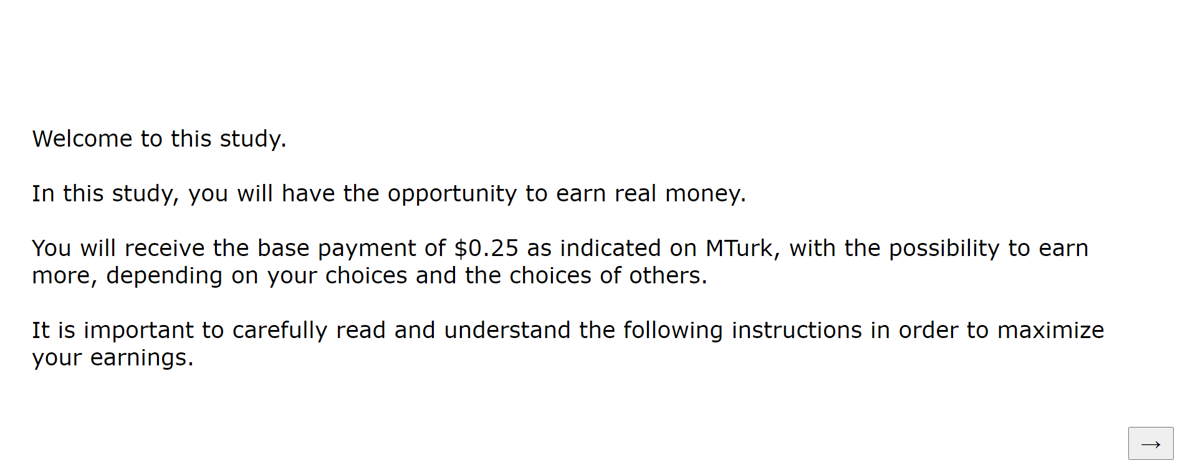
Figure S3 Social Norms Instruction Screen 1

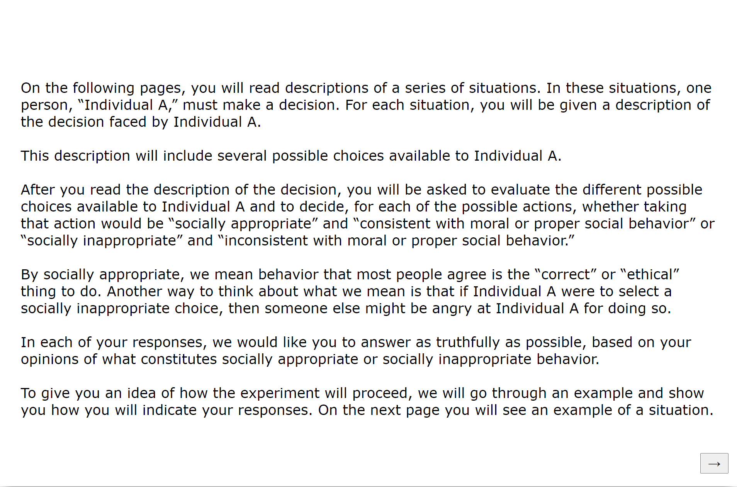
Figure S4 Social Norms Instruction Screen 2

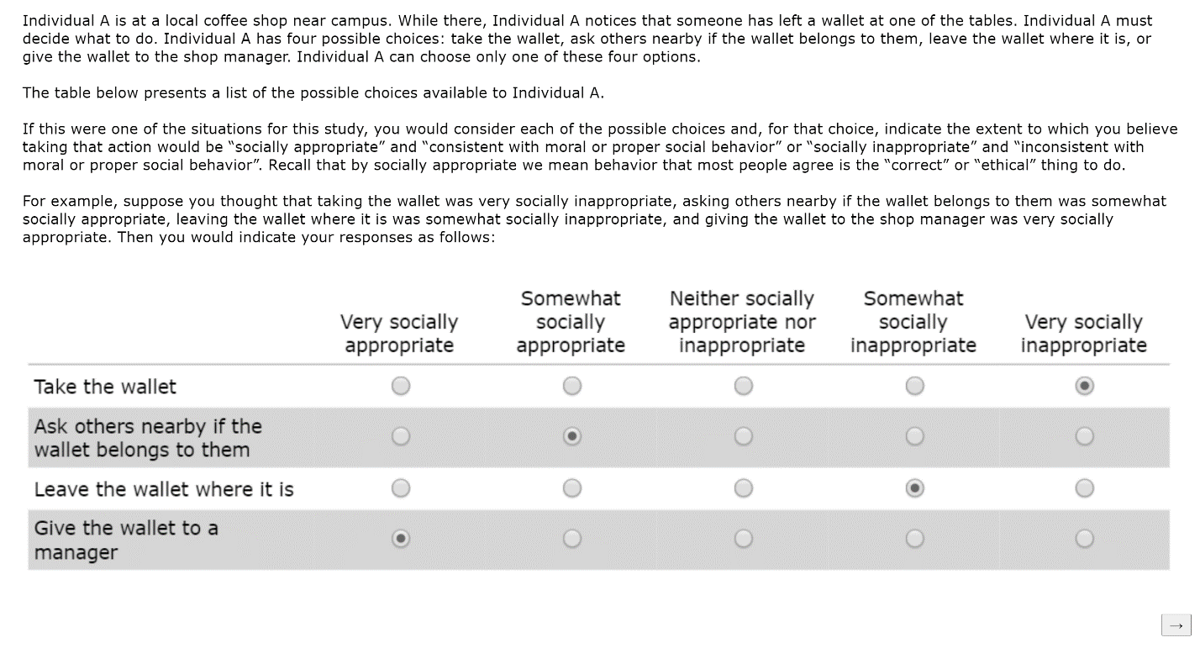
Figure S5 Social Norms Instruction Screen 3

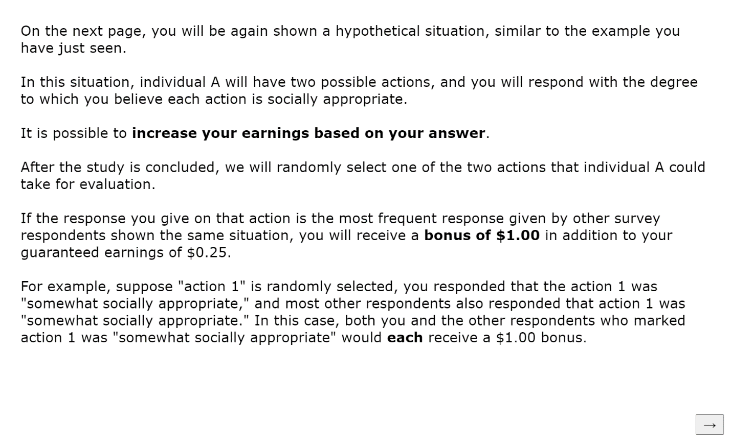
Figure S6 Social Norms Instruction Screen 4
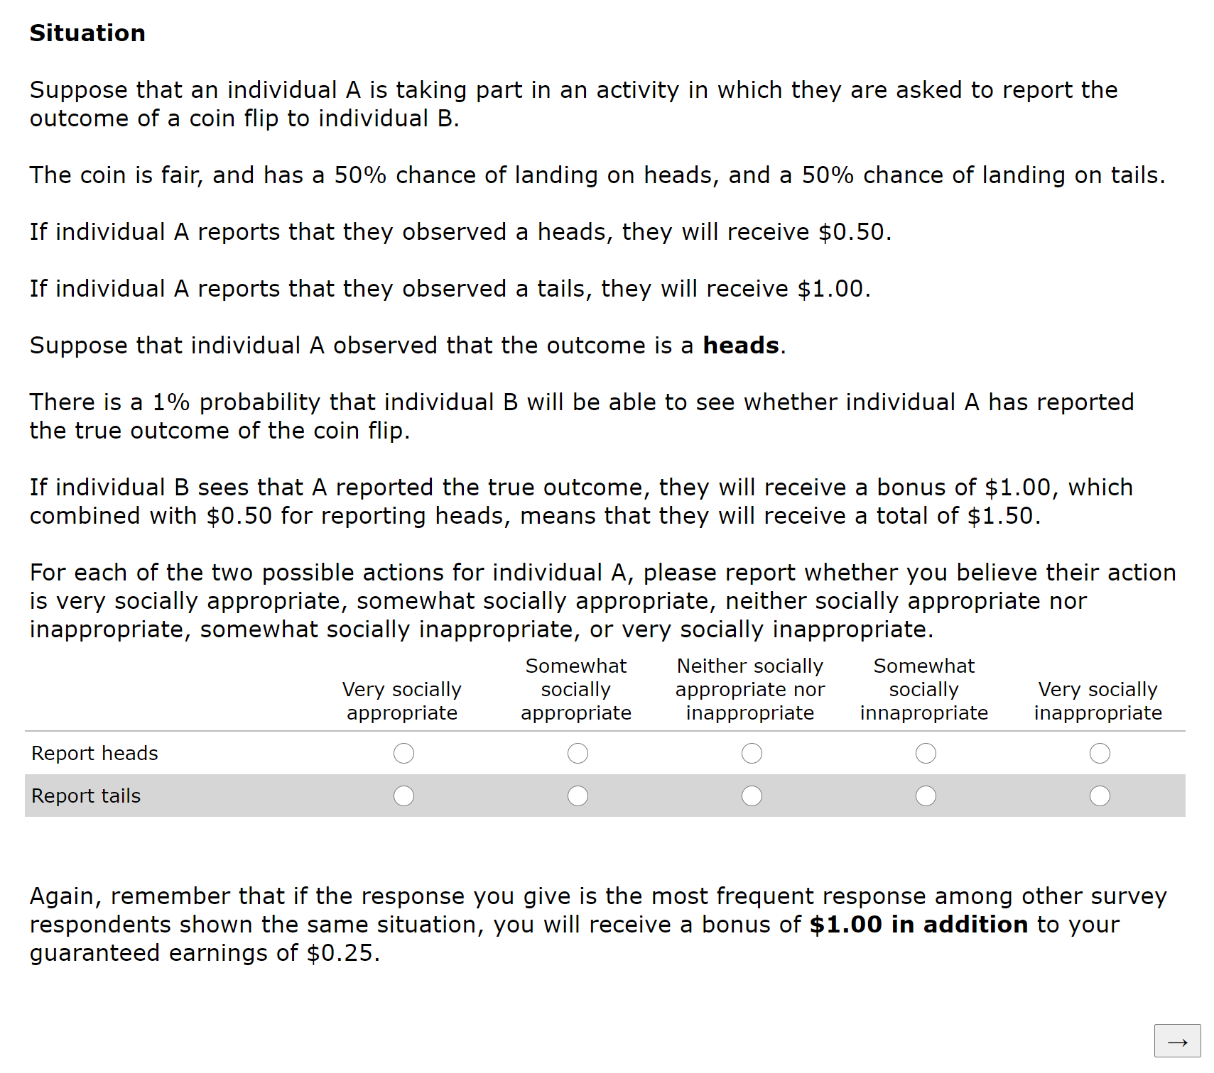
Figure S7 Social Norms Instruction Screen 5

Experiment 2: Results
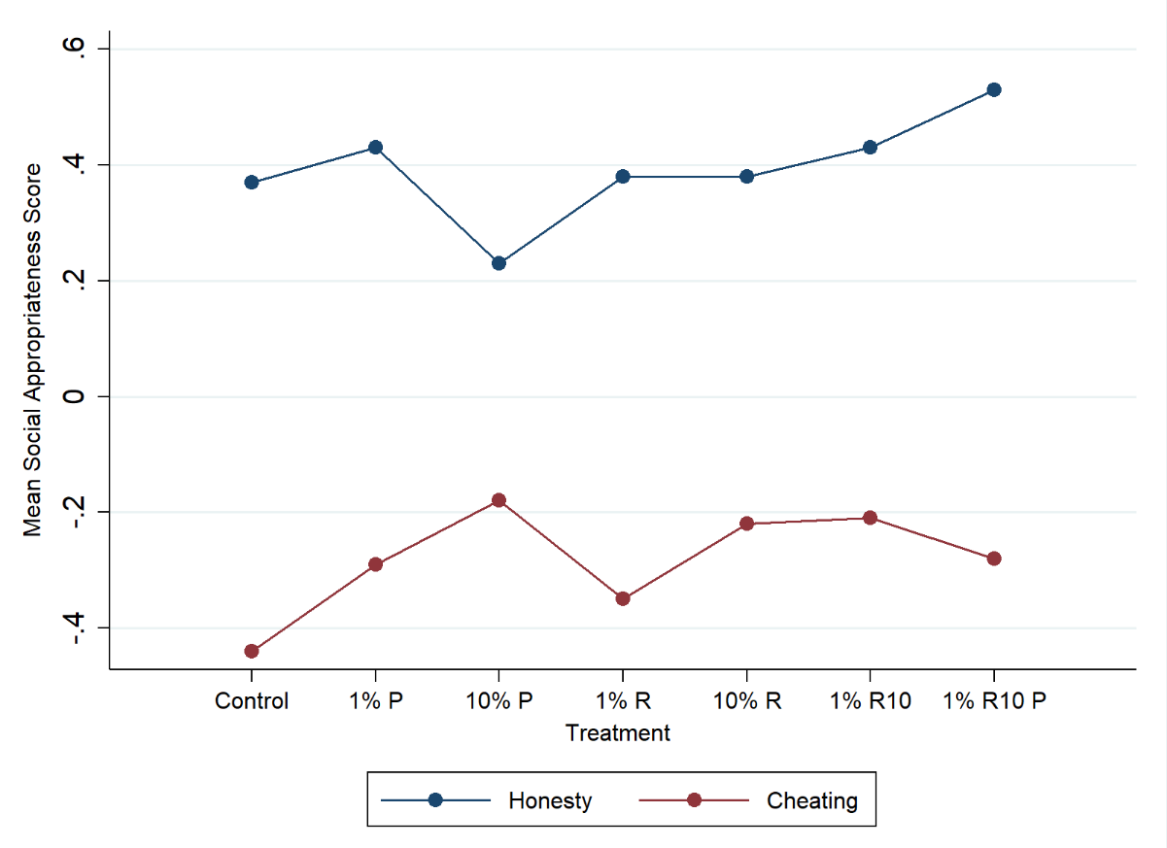
Figure S8 Mean social appropriateness score of cheating and honesty in each treatment} % is audit probability, P indicates punishment for cheating, R indicates reward for honesty, R10 indicates $10 reward. Mean scores calculated by assigning a 1 point for very socially appropriate, 1/3 point for socially appropriate, 0 for neutral, -1/3 for socially inappropriate, -1 for very socially inappropriate.

Treatment | Outcome Reported | Mean | ++ (%) | - (%) | Neutral (%) | - (%) | -- (%)
No Audit  (N = 119) | H | 0.37 | 59 (49.58) | 12 (10.08) | 8 (6.72) | 31 (26.05) | 9 (7.56)
No Audit  (N = 119) | T | -0.44 | 10 (8.40) | 7 (5.88) | 16 (13.45) | 32 (26.89) | 54 (45.38)
1% Punishment (N = 119) | H | 0.43 | 62 (52.10) | 15 (12.61) | 13 (10.92) | 19 (15.97) | 10 (8.40)
1% Punishment (N = 119) | T | -0.29 | 15 (12.61) | 10 (8.40) | 13 (10.92) | 42 (35.29) | 39 (32.77)
10% Punishment (N = 120) | H | 0.23 | 50 (41.67) | 13 (10.83) | 17 (14.17) | 20 (16.67) | 20 (16.67)
10% Punishment (N = 120) | T | -0.18 | 25 (20.83) | 11 (9.17) | 19 (15.83) | 22 (18.33) | 43 (35.83)
1% Reward (N = 120) | H | 0.38 | 57 (47.50) | 14 (11.67) | 20 (16.67) | 19 (15.83) | 10 (8.33)
1% Reward (N = 120) | T | -0.35 | 7 (5.83) | 18 (15.00) | 19 (15.83) | 32 (26.67) | 44 (36.67)
10% Reward  (N = 118) | H | 0.38 | 59 (50.00) | 9 (7.63) | 16 (13.56) | 25 (21.19) | 9 (7.63)
10% Reward  (N = 118) | T | -0.22 | 16 (13.56) | 11 (9.32) | 19 (16.10) | 40 (33.90) | 32 (27.12)
1% R10  (N = 121) | H | 0.43 | 62 (51.24) | 23 (19.01) | 8 (6.61) | 15 (12.40) | 13 (10.74)
1% R10  (N = 121) | T | -0.21 | 18 (14.88) | 17 (14.05) | 13 (10.74) | 36 (29.75) | 37 (30.58)
1% R10P  (N = 119) | H | 0.53 | 69 (57.98) | 20 (16.81) | 10 (8.40 | 11 (9.24) | 9 (7.56)
1% R10P  (N = 119) | T | -0.28 | 18 (15.13) | 16 (13.45) | 16 (13.45) | 19 (15.97) | 50 (42.02)
Table S2 Perceived social appropriateness of cheating and honesty. Number and proportion of respondents who rated each action at a given level of social appropriateness, split by audit probability and punishment or reward. Reporting H corresponds to reporting honestly, reporting T corresponds to reporting dishonestly. % is audit probability, P indicates punishment for cheating, R indicates reward for honesty, R10 indicates $10 reward. Mean scores calculated by assigning a 1 point for very socially appropriate (++), 1/3 point for socially appropriate (+), 0 for neutral, -1/3 for socially inappropriate (-), -1 for very socially inappropriate (--).

Results are presented graphically in Figure S8 and in detail in Table S2. Compared to control, most treatments led to a decrease in the rated inappropriateness of cheating, with the differences generally becoming larger as incentives grew either more probable or larger (with the exception of a large reward and punishment). With honesty, only offering a large reward and punishment was marginally more appropriate than control. Full tables presenting rank-sum tests of equal proportions between all treatments are presented in Table S3 and Table S4.
Participants evaluating the appropriateness of cheating in the cases of a 10% chance of audit and punishment or reward both rated cheating as less inappropriate than control (punishment, rank-sum test, Z = 2.66, (p < 0.01); reward, rank-sum test, Z = 2.79, p = 0.01). Offering just a $10 reward also led to a decrease in the inappropriateness of cheating compared to control (Z = 2.69, p=0.01), and a 1% chance of a $10 reward combined with a punishment led to a marginally lower rating of the inappropriateness of cheating (Z = 1.67, p=0.09). These shifts in norms are consistent with the higher observed rate of cheating with a 10% chance of audit and reward, but counter to the observed behavior with auditing and punishments and/or a large reward. The social appropriateness of cheating was marginally higher with a 1% chance of audit and punishment (Z = 1.78, p = 0.08). This would be consistent with a higher rate of cheating and is thus also contrary to the observed cheating behavior.
Conversely, the social appropriateness of reporting honestly was mostly unaffected by small incentives alone, with the only significant difference that reporting honestly was seen as less socially desirable in the case of a 10% chance of audit and punishment compared to a 1% chance of audit and punishment (Z = -2.00, p = 0.05). A large reward combined with a punishment, however, lead to a higher level of appropriateness of behaving honestly when compared to almost all other treatments, significant when compared to a 10% chance of small punishment (Z = 3.19, p<0.01), control (Z = 1.91, p=0.06), 1% chance of small reward (Z = 1.92, p=0.06), and 10% chance of small reward (Z = 1.71, p=0.07).

Treatment
Treatment |  | 0.1P | 0.01P | 0 | 0.01R | 0.1 R | R10 | R10P
Treatment | 0.1P | X | 1.08 (0.28) | 2.66 (<0.01***) | -1.44 (0.15) | -0.22 (0.83) | -0.18 (0.86) | -0.93 (0.35)
Treatment | 0.01P | X | X | 1.78  ( 0.08*) | -0.27 (0.79) | 1.06  (0.29) | 0.98  (0.33) | 0.05 (0.96)
Treatment | 0 | X | X | X | 1.15  (0.13) | 2.79 (0.01***) | 2.69 (0.01***) | 1.67 (0.09*)
Treatment | 0.01R | X | X | X | X | 1.28  (0.20) | 1.32  (0.19) | 0.45 (0.66)
Treatment | 0.1R | X | X | X | X | X | 0.01  (0.99) | -0.79 (0.43)
Treatment | R10 | X | X | X | X | X | X | -0.83 (0.41)
Treatment | R10P | X | X | X | X | X | X | X
Table S3 Perceived social norms of reporting T (cheating). Rank-sum test of equal proportion of participants who cheated, split by audit probability and punishment (P) or reward (R). Z-score is reported, number in parentheses is p-value. * Indicates p-values less than or equal to 0.1, ** indicates p-values less than or equal to 0.05, *** indicates p-values less than or equal to 0.01.

Treatment
Treatment |  | 0.1P | 0.01P | 0 | 0.01R | 0.1 R | R10 | R10P
Treatment | 0.1P | X | -2.00 (0.05**) | -1.26 (0.21) | 1.46 (0.14) | 1.42 (0.16) | 0.07 (0.94) | 3.19  (<0.01***)
Treatment | 0.01P | X | X | 0.73 (0.46) | -0.60 (0.55) | -0.58 (0.56) | 0.07 (0.94) | 1.23  (0.22)
Treatment | 0 | X | X | X | 0.22 (0.83) | 0.21 (0.83) | 0.74 (0.45) | 1.91  (0.06*)
Treatment | 0.01R | X | X | X | X | -0.04 (0.97) | 0.73 (0.46) | 1.92  (0.06*)
Treatment | 0.1R | X | X | X | X | X | 0.64 (0.52) | 1.81  (0.07*)
Treatment | R10 | X | X | X | X | X | X | 1.15  (0.25)
Treatment | R10P | X | X | X | X | X | X | X
Table S4 Perceived social norms of reporting H (honest report). Rank-sum test of equal proportion of participants who cheated, split by audit probability and punishment (P) or reward (R). Z-score is reported, number in parentheses is p-value. * Indicates p-values less than or equal to 0.1, ** indicates p-values less than or equal to 0.05, *** indicates p-values less than or equal to 0.01.

Experiment 2: Discussion
Experiment 2, which tested the influence of auditing incentives on the social norms of cheating behavior, examined a mechanism to potentially explain why some incentive structures work and some do not. I found, except for a 1% chance of a small punishment, all treatments weakened the norm against cheating when compared with control. While this crowding out is consistent with small rewards being ineffective or backfiring, it is not consistent with small punishments being effective. A 1% chance of a large reward was not associated with norms significantly different from those of a 10% chance of a small reward, despite being associated with a significantly lower rate of cheating. However, the most effective treatment, large punishments combined with rewards, actually led to a stronger norm of honesty.
One possibility is that the large rewards and punishments were merely a particularly salient feature which facilitated participants correctly coordinating on the same norm (Mehta, Starmer, and Sugden, 1994), but did not actually change the genuine norm. A second is that this treatment genuinely changed how participants conceived of the appropriateness of being honest. Taken with the second interpretation, setting large rewards and punishments for desired behavior may have positive effects in creating shifts of social norms in the desired direction that are not achieved with other incentive structures. The data suggests social norms are not a sufficient explanation for the pattern of cheating behavior observed in Experiment 1, but future research may identify whether shifting norms could be a lever for use in auditing incentive design.
Secondly, this experiment contributes to knowledge about the mechanisms through which audits are effective. In addition to changing the expected value of actions, my second experiment provides evidence audits change the perceived social norms of behavior and can either reinforce or detract from the desired behavioral outcome. It also shows though that behavior may not move in the same direction as perceived social norms, leaving the importance of social norms in this context an open question.

S6 Potential Explanations
An important question remains from the results of these two experiments: what can account for the entire observed pattern of cheating behavior?
Two characteristics of prospect theory are consistent with some of the results here: both loss aversion (although notably strong loss aversion) and overweighting of small probabilities are consistent with the largely lower rate of cheating with a 1% chance of audit and punishment. Overweighting of small probabilities though would predict similarly large effects from a 1% chance of audit and reward, which was not observed. Moreover, the higher rate of cheating with small rewards is not predicted by prospect theory.
Another potential explanation is that aspects of the different incentive structures differed in how salient they were to the cheating decision. Punishments may be a particularly salient feature of decisions with an ethical choice, compared to the less-common feature of a reward for good behavior. Participants may, due to their past experience of being punished for unethical actions, place a higher weight on the negative feelings associated with a punishment than the unfamiliar positive feelings of a reward, and in anticipating these feelings, be more motivated by punishments. This would be consistent with punishments generally being more effective than similarly structured rewards, and punishments combining with large rewards to be most effective. Similarly, the size of the reward may be a more salient feature of the decision-making process than the probability of audit (see Laske, Saccardo, and Gneezy 2018 for an example of the size of a punishment being more salient than the probability). Salience alone however does not seem to conveniently explain why crowding out was observed with small rewards but not large rewards.
An explanation which builds on potential differences in how incentive frames are processed emotionally is that audits partially influence behavior according to whether the audits induce fear. When auditing introduces the potential for punishment, it could induce fear or anxiety in some participants, who then behaved to minimize that fear, rather than maximize expected utility, `a la risk-as feelings (Lowenstein et al., 2001). When there is no auditing or auditing and rewards, individuals are not induced into fear or anxiety, and their decision-making process can be captured by an expected utility model. Thus, the asymmetry in the efficacy of rewards and punishments can be explained by an asymmetric emotional response which leads to alternative decision-making processes driving behavior. This interpretation, along with the empirical results of these experiments, leads to two lines of discussion: the first, some potential limits of standard economic reasoning in analyzing the impact of audits, and the second, policy implications and avenues for future research.
Risk-as-feelings (Lowenstein et al., 2001) has been raised as a potentially important explanation for behavior in tax-compliance behavior, including in a real-world tax auditing study (Bergolo et al., 2017). That fear or anxiety is induced is supported by empirical evidence: in related experiments, Coricelli et al. (2010) find that emotional arousal is related to punishments and predictive of tax evasion in the lab, and Dulleck et al. (2016) find correlation between stress markers and compliance during a laboratory tax study. The model holds, among other contentions, that in risky situations which provoke a fear response, behavior will differ from the predictions of expected utility models such as that of Becker (1968) that are predicated upon cognitive evaluation of potential consequences. More precisely, fear is not merely anticipated and brought into the decision-making function (e.g. an individual predicts regret after being punished, which could be modeled as a cost), but changes the evaluative apparatus entirely. This model predicts that individuals in a fearful or anxious state will act to avoid the fear- or anxiety-inducing outcome, while being relatively insensitive to the true probability. Probability neglect, or the insensitivity of individuals to the true probabilities of fearful outcomes is consistent with data from Experiment 1, in the lack of a significant difference between a 1% and 10% chance of audit and punishment, as well as data from the Bergolo et al. (2017) study. This dual-process explanation can accommodate the general efficacy of punishments, as well as social norms being important in the efficacy of rewards. It does have the drawback however of being a complex explanation that post-hoc fits the observations and needs more evidence.
Determining which (if any, or some combination) of these explanations can best explain the impact of auditing incentives is an important avenue for future research. Research similar to Coricelli et al. (2010) or Dulleck et al. (2016) could, through using physiological tools, better establish the proposed dual-process mechanism for cheating behavior in this study. Particularly, functional magnetic resonance imaging could particularly identify differences in brain region activation, to move beyond more general measures of emotional arousal and stress. It is also worth exploring whether emotional or dual-process models of decision making outperform expected utility models in predicting behavior in circumstances where emotional responses may be even stronger, such as when punishment types differ (e.g. prison time vs. fines), or when characteristics of the environment with an emotional potential are more or less salient.

S7 Figures and Tables

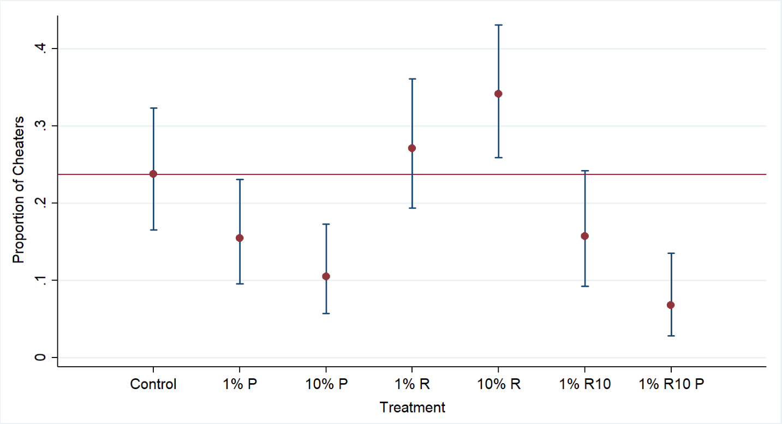
Figure 1. Proportion of participants who cheated in each treatment. Error bars represent 95% binomial exact confidence interval. % is audit probability, P indicates punishment for cheating, R indicates reward for honesty, R10 indicates $10 reward. Horizontal line is rate of cheating in control (no audit).

Treatment (Observed Proportion)
Treatment |  | 10% P (0.10) | 1% P  (0.15) | 0  (0.24) | 1% R  (0.27) | 10% R (0.34) | 1% R10 (0.16) | 1% R10P (0.07)
Treatment | 10% P | X | 0.25 | 0.01*** | <0.01*** | <0.01*** | 0.25 | 0.33
Treatment | 1% P | X | X | 0.10* | 0.03** | <0.01*** | 0.96 | 0.04**
Treatment | 0 | X | X | X | 0.55 | 0.07* | 0.13 | <0.01***
Treatment | 1% R | X | X | X | X | 0.24 | 0.04** | <0.01***
Treatment | 10% R | X | X | X | X | X | <0.01*** | <0.01***
Treatment | 1% R10 | X | X | X | X | X | X | 0.04**
Treatment | 1% R10P | X | X | X | X | X | X | X
Table 2. Pairwise comparisons of cheating rates by treatment} Displayed is the p-value from a (chi^2)-test of equal proportions. Number in parentheses next to each treatment is the proportion of participants who cheated. % is audit probability, P indicates punishment for cheating, R indicates reward for honesty, R10 indicates $10 reward. * Indicates p-values less than or equal to 0.1, ** indicates p-values less than or equal to 0.05, *** indicates p-values less than or equal to 0.01.

S8 Works Cited
  - Abeler, Johannes, Daniele Nosenzo, and Collin Raymond. "Preferences for truth‐telling." Econometrica 87.4 (2019): 1115-1153.
  - Andreoni, James, William Harbaugh, and Lise Vesterlund. "The carrot or the stick: Rewards, punishments, and cooperation." American Economic Review 93.3 (2003): 893-902.
  - Battigalli, Pierpaolo, Gary Charness, and Martin Dufwenberg. "Deception: The role of guilt." Journal of Economic Behavior & Organization 93 (2013): 227-232.
  - Becker, Gary S. "Crime and punishment: An economic approach." The economic dimensions of crime. Palgrave Macmillan UK, 1968. 13-68.
  - Benartzi, Shlomo, and Richard H. Thaler. "Myopic loss aversion and the equity premium puzzle." The quarterly journal of Economics 110.1 (1995): 73-92.
  - Bérgolo, Marcelo L., et al. Tax audits as scarecrows: Evidence from a large-scale field experiment. No. w23631. National Bureau of Economic Research, 2017.
  - Cappelen, Alexander W., Erik Ø. Sørensen, and Bertil Tungodden. "When do we lie?." Journal of Economic Behavior & Organization 93 (2013): 258-265.
  - Coricelli, Giorgio, et al. "Cheating, emotions, and rationality: an experiment on tax evasion." Experimental Economics 13.2 (2010): 226-247.
  - Dufwenberg, Martin. "Lies in Disguise-A Theoretical Analysis of Cheating." (2016).
  - Dulleck, Uwe, et al. "Tax compliance and psychic costs: behavioral experimental evidence using a physiological marker." Journal of Public Economics 134 (2016): 9-18.
  - Garrett, Thomas A., and Russell S. Sobel. "Gamblers favor skewness, not risk: Further evidence from United States’ lottery games." Economics Letters 63.1 (1999): 85-90.
  - Genesove, David, and Christopher Mayer. "Loss aversion and seller behavior: Evidence from the housing market." The Quarterly Journal of Economics 116.4 (2001): 1233-1260.
  - Gneezy, Uri. The W effect of incentives. University of Chicago working paper, (2003).
  - Gneezy, Uri, Agne Kajackaite, and Joel Sobel. "Lying Aversion and the Size of the Lie." American Economic Review 108.2 (2018): 419-53.
  - Gneezy, Uri, and Jan Potters. "An experiment on risk taking and evaluation periods." The Quarterly Journal of Economics 112.2 (1997): 631-645.
  - Gneezy, Uri, Bettina Rockenbach, and Marta Serra-Garcia. "Measuring lying aversion." Journal of Economic Behavior & Organization 93 (2013): 293-300.
  - Gneezy, Uri, and Aldo Rustichini. "A fine is a price." The Journal of Legal Studies 29.1 (2000): 1-17.
  - Gneezy, Uri, and Aldo Rustichini. "Incentives, punishment and behavior." Advances in behavioral economics (2004): 572-89.
  - Kajackaite, Agne, and Uri Gneezy. "Incentives and cheating." Games and Economic Behavior 102 (2017): 433-444.
  - Kahneman, Daniel, and Amos Tversky. "Prospect Theory: An Analysis of Decision under Risk." Econometrica 47.2 (1979): 263-292.
  - Khalmetski, Kiryl, and Dirk Sliwka. 2019. "Disguising Lies--Image Concerns and Partial Lying in Cheating Games." American Economic Journal: Microeconomics, 11 (4): 79-110.
  - Lochner, Lance, and Enrico Moretti. "The effect of education on crime: Evidence from prison inmates, arrests, and self-reports." American economic review 94.1 (2004): 155-189.
  - Mehta, Judith, Chris Starmer, and Robert Sugden. "The nature of salience: An experimental investigation of pure coordination games." The American Economic Review 84, no. 3 (1994): 658-673.
  - Shalvi, S., Eldar, O. & Bereby-Meyer, Y. Honesty requires time (and lack of justifications). Psychological science 23 (2012): 1264-1270

